Type of the Paper (Article, Review, etc.)

Article Title
Author Firstname Lastname ¹, Firstname Lastname ² and Firstname Lastname ^{2,}*
Affiliation: ¹Institute, Department, University, City, State or Province, Country; e-mail@e-mail.com
²Institute, Department, University, City, State or Province, Country; e-mail@e-mail.com
* Correspondence: abc@example.com (email address of the corresponding author)

Abstract: Type or paste your text here. The Abstract should be no more than 250 words and should: i) include a succinct summary of the background, ii) clearly state the problem or lack of information being addressed, ii) briefly describe the methods, iii) state the main findings, and iv) summarize the conclusions and broader implications of the research. Avoid undefined abbreviations and references to the literature. The trial registration number (TRN) and date of registration, followed by funding source, should be included as the last line of the Abstract for Clinical Trials. Diagnostic/prognostic studies should follow STARD guidelines for Abstracts. Detailed information can be found in the author guidelines on the journal's website.
Keywords: keyword 1; keyword 2; You may list up to 6 keywords that are closely related to the manuscript topic yet common enough in the subject area.
Citation:
1. Introduction
The Introduction is an overview of the relevant current literature, informing the reader why the topic is important. highlighting the main problem or question being investigated, the hypothesis or objectives of the study, and (if useful) the approach being taken. Please refrain from presenting the main results here. In-text citations should be numbered according to the order in which they appear in the main text, given as non-italicized numbers within brackets: [15,16]; [15–20]; [15,18–20]. For detailed information please refer to the "References'' section below.
2.Materials and Methods

Materials and methods should be written in sufficient detail that the work can be repeated by another competent researcher, should be presented in a logical order, should be divided by topical subheadings, and should contain an ethics statement if applicable. Include a dedicated section to describe statistical analyses if applicable. For novel methodologies and protocols, thorough descriptions are necessary, whereas established methods can be summarized with proper citation. Manuscripts reporting extensive datasets deposited in public databases should specify the data's location and relevant accession numbers. If these numbers are unavailable at submission, mention that they will be provided during review but must be included before publication. Studies involving interventions on animals or humans, as well as those requiring ethical approval, should include the approving authority and the corresponding ethical approval code.
3. Results
Objective and logical presentation of the findings using both text and display items (Tables and Figures). If appropriate, the results of statistical analyses should also be presented here, including P-values and/or other statistical measures of significance. All data should be incorporated either within the main text or in the Supplementary Materials. If that is not possible, data should be deposited in an established database and accession numbers provided in the Data Availability section of the manuscript. If tables exceed two pages, it is recommended to include them as supplementary material. See the Editorial Policies for more detail on the availability of data, materials, and code. References to unpublished materials are not permitted to substantiate significant conclusions of the paper.
Please add Figures, Tables and Schemes
All figures and tables should be cited in the main text as Figure 1, Table 1, etc.

1. Formatting: Heading 1 style
Within the article, you may insert 4 heading levels into your submission. The styles for each are listed here.

Formatting: Heading 2 style

Type or paste your text here.

Formatting: Heading 3 style

Type or paste your text here.

Formatting: Heading 4 style, unnumbered

Type or paste your text here.
2. Formatting: Lists
- Follow this format for bulleted lists
- Follow this format for numbered lists
3. Formatting: Equations
Equations should be editable and should be numbered in the order that they appear in the text. We recommend using the MathType equation editor.
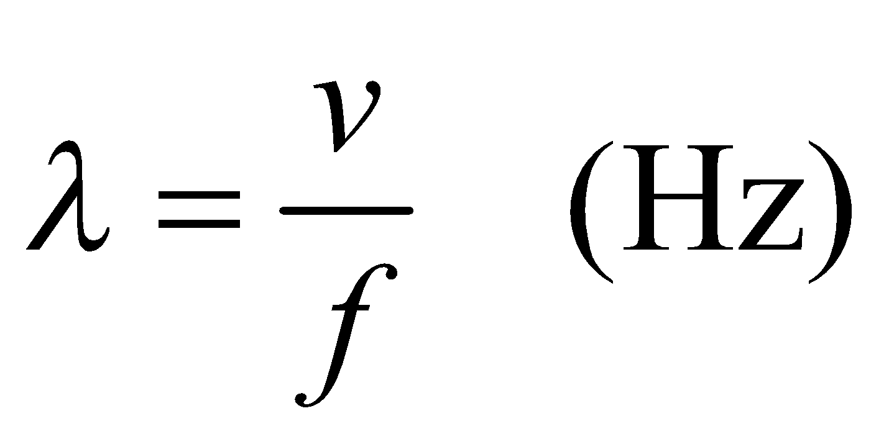<<The example equation uses MathType>> ( X)
4. Discussion
This section should highlight the importance and novelty of the work and discuss the implications of the findings in the context of the existing understanding in the field. Refrain from providing more background information or repeating the results here. The limitations of the study should also be objectively discussed. If a Conclusions section is not included separately, please also include a dedicated paragraph to discuss the broader and/or real world implications of the results and future work.
5. Conclusions

The main conclusions of the paper may also be presented as a short Conclusions section. Conclusions should be consistent with the scope of the work and appropriately broad and forward thinking. This section can also indicate areas for future research and inform on the implications and/or real-world applications of the work.
Patents (optional): This section may be added if there are patents resulting from the work reported in this manuscript.
Acknowledgments: Acknowledgments statement gives credit to those who contributed to the manuscript but did not meet the criteria for authorship. Personal communications should include a letter of permission and may be acknowledged in the Acknowledgements section.
Funding: The names of funders / funding institutions should be provided in full and grant numbers / identifiers given. For example: “This work was supported by the National Institutes of Health [grant numbers xxxx, yyyy] and the National Science Foundation [grant number zzzz].” Report funding sources for publication as, “The APC was funded by [XXX]”. If there are no funding sources, please include, “There are no sources of funding to declare.”
Author contributions: An author contributions statement should be included in all submitted manuscripts to specify the work of each author. A short paragraph must be provided using the following statement: “Conceptualization, X.X. and Y.Y.; methodology, X.X.; software, X.X.; validation, X.X., Y.Y. and Z.Z.; formal analysis, X.X.; investigation, X.X.; resources, X.X.; data curation, X.X.; writing—original draft preparation, X.X.; writing—review and editing, X.X.; visualization, X.X.; supervision, X.X.; project administration, X.X.; funding acquisition, Y.Y. All authors have read and agreed to the published version of the manuscript.” For the explanation of each term, you can refer to CRediT taxonomy.
Conflict of interest: The conflict-of-interest statement should disclose any conflict of interest due to financial, personal, academic interest, or any other factor that may be perceived to influence the objectivity, integrity or value of the study. If there is no conflict of interest, please state: "The author(s) declare no conflict of interest."
Data availability statement: The data availability statement should explain where data in the manuscript is stored and how it can be accessed, including links as appropriate. If authors are unsure where to store their data, unstructured repositories such as Dryad, Zenodo and Figshare should be considered. If all data is included in this article, please state: "Data supporting these findings are available within the article or upon request."
Institutional review board statement: For studies involving humans, please incorporate the following statement: "The study was conducted in accordance with the Declaration of Helsinki and approved by the Institutional Review Board (or Ethics Committee) of [NAME OF INSTITUTE] (protocol code XXX and date of approval)." For studies involving animals, please use the following statement: "The animal study protocol was approved by the Institutional Review Board (or Ethics Committee) of [NAME OF INSTITUTE] (protocol code XXX and date of approval)." For cases where ethical review and approval were waived, please provide a detailed justification under: "Ethical review and approval were waived for this study due to [REASON]." For studies not involving humans or animals, please simply state: "Not applicable.
Informed consent statement: Please include one of the following options: "Informed consent was obtained from all subjects involved in the study," or "Patient consent was waived due to [REASON] (please provide a detailed justification)," or "Not applicable," for studies not involving humans. For studies involving identifiable patients, written informed consent for publication must be acquired from the participants or their legal representatives. If applicable, please state: "Written informed consent has been obtained from the patient(s) to publish this paper."
Sample availability: Please use this section to provide a statement on the availability of physical samples used in the study, including information on how interested parties can access these samples or details on how to request access. If no physical samples are used, please include the following statement: "The author(s) declare that no physical samples were used in this study.
Supplementary materials: Should include materials and methods, checklists for reporting guidelines (if applicable), figures, tables, text, videos (.mp4), audio (.mp3), and/or data or methods that were not included in the manuscript. All supplementary materials must be cited in the main manuscript in numerical order (Supplementary Figure 1, 2, 3, etc). Both table and figure captions should include enough information that they are able to be interpreted independently of the text. The following statement should be included in this section: "The supplementary materials are available at [Link to resource location]".
Additional information
Received: YYYY-MM-DD
Accepted: YYYY-MM-DD
Published: YYYY-MM-DD
References: Formatted according to the Vancouver style (also referred to as ICMJE and Uniform Requirements Style). References should be numbered according to the order in which they appear in the text, then figure and table legends, and finally Supplementary Materials (i.e., each reference should receive a unique number). Citations in the main text are given as non-italicized numbers within brackets: [15,16]; [15–20]; [15,18–20] and should come after periods and commas but before colons and semicolons. Reference lists should include the full list of authors, title, pagination or article number, and publication year. For references with greater than five authors, the first author is stated in style and then ‘et al.’ is used for all additional authors. For more details, please see the references and citations style guide on the journal website.
Publisher’s note: Academia.edu Journals stays neutral regarding jurisdictional claims in published maps and institutional affiliations. All claims expressed in this article are solely those of the authors and do not necessarily represent those of their affiliated organizations, or those of the publisher, the editors, and the reviewers. Any product that may be evaluated in this article, or claim that may be made by its manufacturer, is not guaranteed or endorsed by the publisher.
Copyright: © 20xx copyright by the authors. This article is an open access article distributed under the terms and conditions of the Creative Commons Attribution (CC BY) license (https:// creativecommons.org/licenses/by/4.0/).

